|  |  |
| --- | --- |
| Date | 19 Nov 2022 |
| Team ID | PNT2022TMID40818 |
| Project Name | Natural Disaster Intensity Analysis and Classification Using AI |

CYLONE

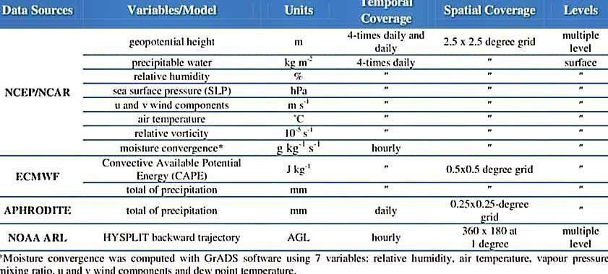

EARTH QUAKE

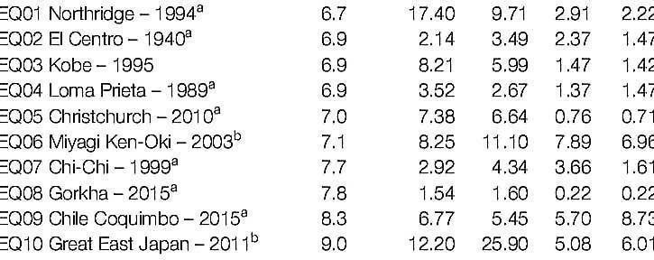

WILDLIFE

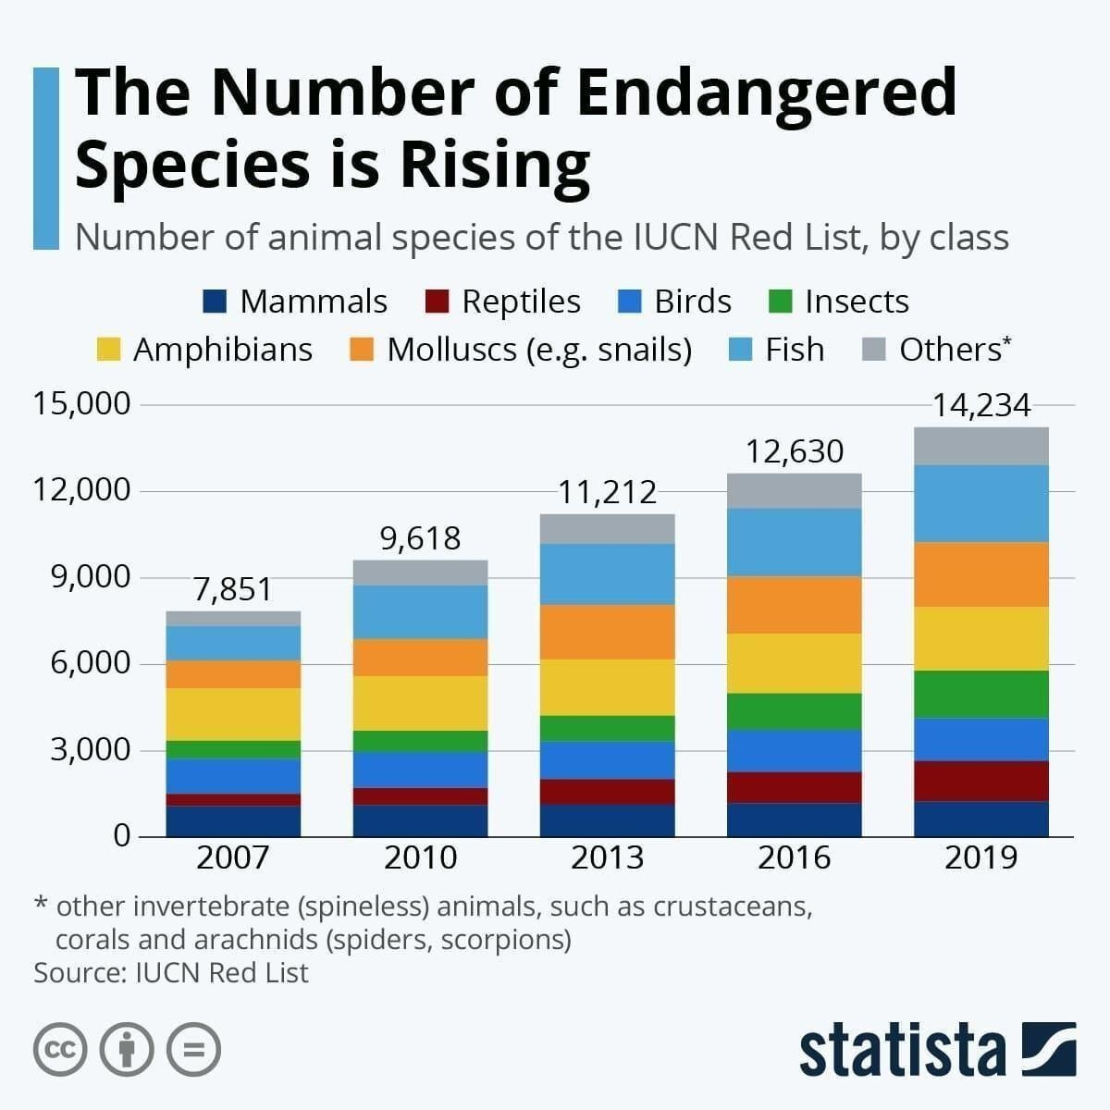

FLOOD

